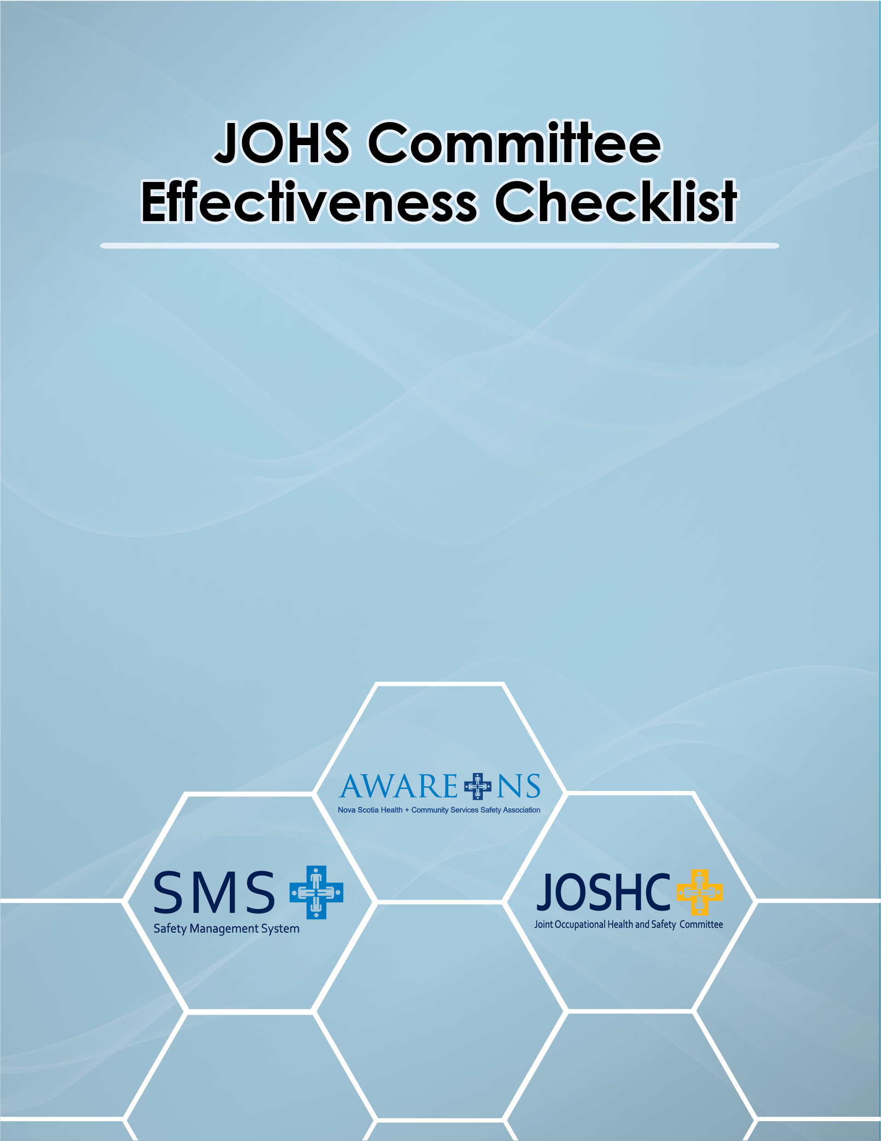
JOHSC Effectiveness Checklist
JOINT OH&S COMMITTEE AUDIT | AUDIT RATING |  |  |  |  |  |  | AUDIT EXPECTATIONS
 | Response |  | Points  Available | Technique |  |  | Points  Awarded
 | Yes | No |  | D | P | I
QUESTIONS:
- Is a JOH&S Committee established where  required? |  |  | 1 |  |  |  |  | Workplaces with 20 or more regular employees require a JOH&S Committee  OH&S Act: C.7, S.29.
- Does the JOH&S Committee have established Rules of Procedure? |  |  | 1 |  |  |  |  | Must be documented. Rules of Procedures for JOH&S  Committees must be specific to the Committee at that location.  OH&S Act: C.7, S.30
- Do the Rules of Procedure include clear documentation of the functions of the JOH&S Committee and its method of operation? |  |  | 1 |  |  |  |  | Should include functions of the JOH&S Committee, method of appointing committee members and chairperson, meeting frequency, preparation and posting of minutes, and making of recommendations. Must be specific to the Committee at that location.  OH&S Act: C.7, S.30.
Audit Rating Key: D: Documented P: Posted I: Indicated Page 1 of 7

JOINT OH&S COMMITTEE AUDIT | AUDIT RATING |  |  |  |  |  |  | AUDIT EXPECTATIONS
 | Response |  | Points Available | Technique |  |  | Points  Awarded
 | Yes | No |  | D | P | I
QUESTIONS:
- Have JOH&S Committee members received OH&S  training? |  |  | 1 |  |  |  |  | Training should include OH&S Act, JOH&S Committee Responsibilities and Rules of Procedure, Inspection and Investigation Procedures.  JOH&S Committee Question: Have you received Occupational Health and Safety Training to help you understand the role and responsibilities of JOH&S Committees and how to perform your duties?  OH&S ACT: C.7, S. 28(2a)
- Are JOH&S Committee Members aware of their responsibilities? |  |  | 1 |  |  |  |  | Compare answer to the lists in the OH&S Act.  OH&S Act: C.7, S.31  OH&S Committee Question: Describe the responsibilities of the JOH&S Committee under the OH&S Act.
Audit Rating Key: D: Documented P: Posted I: Indicated Page 2 of 7

JOINT OH&S COMMITTEE AUDIT | AUDIT RATING |  |  |  |  |  |  | AUDIT EXPECTATIONS
 | Response |  | Points  Available | Technique |  |  | Points  Awarded
 | Yes | No |  | D | P | I
QUESTIONS:
- Is a list of JOH&S Committee members posted at each permanent workplace? |  |  | 1 |  |  |  |  | Must be current.  OH&S Act: C.7, S.37
- Are JOH&S Committee minutes posted? |  |  | 1 |  |  |  |  | Must be current.  OH&S Act: C.7, S.37
- Does the JOH&S Committee make recommendations to a level of management with the authority to resolve health and safety issues? |  |  | 1 |  |  |  |  | Important to get things done. Must be a level with authority to resolve health and safety issues.  JOH&S Committee Question: To whom does the JOH&S Committee make recommendations?  OH&S ACT: C.7, S. 28 (2c)
- Are action items from the minutes addressed in a  timely manner? |  |  | 1 |  |  |  |  | Examine the minutes. Must not be carried forward from meeting to meeting with no action or progress. OH&S ACT: C.7, S. 30
Audit Rating Key: D: Documented P: Posted I: Indicated Page 3 of 7

JOINT OH&S  COMMITTEE AUDIT | AUDIT RATING |  |  |  |  |  |  | AUDIT EXPECTATIONS
 | Response |  | Points  Available | Technique |  |  | Points  Awarded
 | Yes | No |  | D | P | I
QUESTIONS:
- Do JOH&S Committee members participate in workplace inspections? |  |  | 1 |  |  |  |  | JOH&S Committee Question: Do JOH&S Committee members participate in workplace inspections?  OH&S Act: C. 7, S. 31 and 33(6)
- Are JOH&S Committee members involved in incident  investigations? |  |  | 1 |  |  |  |  | JOH&S Committee Question: Do JOH&S Committee members participate in incident investigations?  OH&S Act: C.7, S. 31 and 33(6)
- Are JOH&S Committee members involved in the  development of safe work procedures? |  |  | 1 |  |  |  |  | JOH&S Committee Question: Do JOH&S Committee members participate in the development or review of safe work procedures?  OH&S Act: C.7, S. 31 and 33(6)
Audit Rating Key: D: Documented P: Posted I: Indicated Page 4 of 7

JOINT OH&S  COMMITTEE AUDIT | AUDIT RATING |  |  |  |  |  |  | AUDIT EXPECTATIONS
 | Response |  | Points  Available | Technique |  |  | Points  Awarded
 | Yes | No |  | D | P | I
Questions:
- Did the JOH&S Committee participate in the  development of the department’s OH&S Program? |  |  | 1 |  |  |  |  | JOH&S Committee Question: Did the JOH&S Committee participate in the development of the agency’s OH&S Program?  OH&S Act: C.7, S. 28 and 31
- Does the JOH&S Committee undertake a yearly review of the WHMIS Training Program? |  |  | 1 |  |  |  |  | JOH&S Committee Question: Did the JOH&S Committee undertake a review of the agency’s WHMIS Training Program during the past year?  WHMIS Regulations, S.5(3)
- Does or will a JOH&S Committee member accompany a Department of Labour OH&S Officer on inspections or investigations? |  |  | 1 |  |  |  |  | JOH&S Committee Question: Does (or will), a JO&S Committee member accompany a Department of Labour OH&S Officer on inspections or investigations?  OH&S Act: C.7, S. 31, 33 and 50
Audit Rating Key: D: Documented P: Posted I: Indicated Page 5 of 7

JOINT OH&S COMMITTEE AUDIT | AUDIT RATING |  |  |  |  |  |  | AUDIT EXPECTATIONS
 | Response |  | Points  Available | Technique |  |  | Points  Awarded
 | Yes | No |  | D | P | I
QUESTIONS:
- Where workplace monitoring is undertaken, is the OH&S Committee informed of the monitoring activities, allowed to observe or otherwise be involved, and given a copy of all monitoring results? |  |  | 1 |  |  |  |  | JOH&S Committee Question: Where workplace monitoring is undertaken, is the OH&S Committee informed of the monitoring activities, allowed to observe or otherwise be involved, and given a copy of all monitoring results?  - Include only if applicable  OH&S Act: C. 7, S. 35
- Is the JOH&S Committee involved in the investigation of OH&S complaints which are not resolved at the supervisor level? |  |  | 1 |  |  |  |  | JOH&S Committee Question: Is the JOH&S Committee involved in the investigation of OH&S complaints, which are not resolved at the supervisor level?  OH&S Act: C.7, S. 31 and 33(6)
Audit Rating Key: D: Documented P: Posted I: Indicated Pages 6 of 7

JOINT OH&S  COMMITTEE AUDIT | AUDIT RATING |  |  |  |  |  |  | AUDIT EXPECTATIONS
 | Response |  | Points  Available | Technique |  |  | Points  Awarded
 | Yes | No |  | D | P | I
Questions:
- Is the JOH&S Committee involved in Work Refusals under the OHS Act which are not resolved at the supervisor level? |  |  | 1 |  |  |  |  | JOH&S Committee Question: Is the JOH&S Committee involved in Work Refusals under the OHS Act which are not resolved at the supervisor level?  OH&S Act: C.7, S.43
TOTALS |  |  | 18
Audit Rating Key: D: Documented P: Posted I: Indicated Page 7 of 7
Date:_______ Auditor’s Signature:____________________ Name & Title_________________
(Please Print)

Date:_______ Manager’s Signature:____________________ Name & Title________________
(Please Print)

